25

Windows Communication Foundation
[AU: I’ve gone with the previous style for now, but can I make yet another plea for getting rid of the stupid, unnecessary capitalization of “Web” and “Internet”?]
[AU: Quite a few changes relating to the removal of the earlier Web Services chapter. The only thing that still bugs me slightly is that now there is no real description of SOAP. However, this isn’t necessarily a major problem as it’s not necessary to understand SOAP to use WCF, it’s just a point of interest. Note also that SOAP no longer stands for Simple Object Access Protocol. It doesn’t stand for anything any more. Not really sure why.]
What You Will Learn in This Chapter
What is WCF?
WCF concepts
WCF programming

Wrox.com Code Downloads for This Chapter
You can find the wrox.com code downloads for this chapter at www.wrox.com/remtitle.cgi?isbn=9781118314418 on the Download Code tab. The code is in the Chapter 25 download and individually named according to the names throughout the chapter.
In recent years, as use of the Internet has become more ubiquitous, there has been a rapid increase in “Web services.” A Web service is like a Web site that is used by a computer instead of a person. For example, instead of browsing to a Web site about your favorite TV program, you might instead use a desktop application that pulled in the same information via a Web service. The advantage here is that the same Web service might be used by all sorts of applications, and, indeed, by Web sites. Also, you can write your own application or Web site that uses third-party Web services. Perhaps you might combine information about your favorite TV program with a mapping service to show filming locations.
The .NET Framework has supported Web services for some time now. However, in the more recent versions of the framework, Web services have been combined with another technology, called remoting, to create Windows Communication Foundation (WCF), which is a generic infrastructure for communication between applications. R
emoting makes it possible to create instances of objects in one process and use them from another process—even if the object is created on a computer other than the one that is using it. However, remoting on its own is limited, and isn't the easiest thing for a beginner programmer to learn.
WCF takes concepts such as services and platform-independent SOAP messaging from Web services, and combines these with concepts such as host server applications and advanced binding capabilities from remoting. The result is a technology you can think of as a superset that includes both Web services and remoting, but that is much more powerful than Web services and much easier to use than remoting. Using WCF, you can move from simple applications to applications that use a service-oriented architecture (SOA). SOA means that you decentralize processing and make use of distributed processing by connecting to services and data as you need them across local networks and the Internet.
In this chapter, you learn about the principles behind WCF and how you can create and consume WCF services from your application code.

What Is WCF?
WCF is a technology that enables you to create services that you can access from other applications across process, machine, and network boundaries. You can use these services to share functionality across multiple applications, to expose data sources, or to abstract complicated processes.
The functionality that WCF services offer is encapsulated as individual methods that are exposed by the service. Each method—or, in WCF terminology, each operation—has an endpoint that you exchange data with in order to use it. This data exchange can be defined by one or more protocols, depending on the network that you connect to the service through and your specific requirements.
In WCF, an endpoint can have multiple bindings, each of which specifies a means of communication. Bindings can also specify additional information, such as what security requirements must be met to communicate with the endpoint. A binding might require username and password authentication or a Windows user account token, for example. When you connect to an endpoint, the protocol that the binding uses affects the address that you use, as you will see shortly.
Once you have connected to an endpoint, you can communicate with it by using SOAP messages. The form of the messages that you use depends on the operation you are using, and the data structures that are required to send messages to, and receive messages from, that operation. WCF uses contracts to specify all of this. You can discover contracts through metadata exchange with a service. One commonly used format for service discovery is the Web Service Description Language (WSDL) originally used for Web services, although WCF services can also be described in other ways.
When you have identified a service and endpoint that you want to use, and after you know what binding you use and what contracts to adhere to, you can communicate with a WCF service as easily as with an object that you have defined locally. Communications with WCF services can be simple, one-way transactions, request/response messages, or full-duplex communications that can be initiated from either end of the communication channel. You can also use message payload optimization techniques, such as Message Transmission Optimization Mechanism (MTOM) to package data if required.
The WCF service itself may be running in one of a number of different processes on the computer where it is hosted. Unlike Web services, which always run in IIS, you can choose a host process that is appropriate to your situation. You can use IIS to host WCF services, but you can also use Windows services or executables. If you are using TCP to communicate with a WCF service over a local network, there is no need even to have IIS installed on the PC that is hosting the service.
The WCF framework has been designed to enable you to customize nearly everything you have read about in this section. However, this is an advanced subject and you will only be using the techniques provided by default in .NET 4.5 in this chapter.
Now that you have covered the basics about WCF services, you will look in more detail at these concepts in the following sections.

WCF Concepts
This section describes the following aspects of WCF:
- WCF communication protocols
- Addresses, endpoints, and bindings
- Contracts
- Message patterns
- Behaviors
- Hosting

WCF Communication Protocols
As described earlier, you can communicate with WCF services through a variety of transport protocols. In fact, five are defined in the .NET 4.5 Framework:
- HTTP. This enables you to communicate with WCF services from anywhere, including across the Internet. You can use HTTP communications to create WCF Web services.
- TCP. This enables you to communicate with WCF services on your local network or across the Internet if you configure your firewall appropriately. TCP is more efficient than HTTP and has more capabilities, but it can be more complicated to configure.
- UDP. This is similar to TCP in that is enables communications via the local network or Internet, but is implemented in a subtly different way. One of the consequences of this implementation, which you won’t look at in detail, is that a service can broadcast messages to multiple clients simultaneously. The UDP protocol is new the .NET 4.5 Framework, although previously third-party implementations were available.
- Named pipe. This enables you to communicate with WCF services that are on the same machine as the calling code, but reside in a separate process.
- MSMQ. This is a queuing technology that enables messages sent by an application to be routed through a queue to arrive at a destination. MSMQ is a reliable messaging technology that ensures that a message sent to a queue will reach that queue. MSMQ is also inherently asynchronous, so a queued message will only be processed when messages ahead of it in the queue have been processed and a processing service is available.
These protocols often enable you to establish secure connections. For example, you can use the HTTPS protocol to establish a secure SSL connection across the Internet. TCP offers extensive possibilities for security in a local network by using the Windows security framework. UDP doesn’t support security.
Figure 25-1 illustrates how these transport protocols can connect an application to WCF services in various locations (UDP and TCP connect in a similar way, so only TCP is shown). This chapter describes all of these protocols except for MSMQ, which is a subject requiring a more in-depth discussion.
Figure 25-1 [314418 f2501.eps]
[AU: Existing line art is fine here.]
In order to connect to a WCF service, you must know where it is. In practice, this means knowing the address of an endpoint.

Addresses, Endpoints, and Bindings
The type of address you use for a service depends on the protocol that you are using. Service addresses are formatted for the three protocols described in this chapter (MSMQ is not covered) as follows:
- HTTP. —Addresses for the HTTP protocol are URLs of the familiar form http://<server>:<port>/<service>. For SSL connections, you can also use https://<server>:<port>/<service>. If you are hosting a service in IIS, <service> will be a file with a .svc extension. IIS addresses will probably include more subdirectories than this example—that is, more sections separated by / characters before the .svc file.
- TCP. —Addresses for TCP are of the form net.tcp://<server>:<port>/<service>.
- UDP. —Addresses for UDP are of the form soap.udp://<server>:<port>/<service>. Certain <server> values are required for multicast communications, but this is beyond the scope of this chapter.
- Named pipe. —Addresses for named pipe connections are similar but have no port number. They are of the form net.pipe://<server>/<service>.
The address for a service is a base address that you can use to create addresses for endpoints representing operations. For example, you might have an operation at net.tcp://<server>:<port>/<service>/operation1.
For example, imagine you create a WCF service with a single operation that has bindings for all three of the protocols listed here. You might use the following base addresses:
http://www.mydomain.com/services/amazingservices/mygreatservice.svc
net.tcp://myhugeserver:8080/mygreatservice
net.pipe://localhost/mygreatservice
You could then use the following addresses for operations:
http://www.mydomain.com/services/amazingservices/mygreatservice.svc/greatop
net.tcp://myhugeserver:8080/mygreatservice/greatop
net.pipe://localhost/mygreatservice/greatop
Since .NET 4, it has been possible to use default endpoints for operations, without having to explicitly configure them. This simplifies configuration, especially in situations where you want to use standard endpoint addresses, as in the preceding examples.
Bindings, as mentioned earlier, specify more than just the transport protocol that will be used by an operation. You can also use them to specify the security requirements for communication over the transport protocol, transactional capabilities of the endpoint, message encoding, and much more.
Because bindings offer such a great degree of flexibility, the .NET Framework provides some predefined bindings that you can use. You can also use these bindings as starting points, tweaking them to obtain exactly the type of binding you want—up to a point. The predefined bindings have certain capabilities to which you must adhere. Each binding type is represented by a class in the System.ServiceModel namespace. The following table lists these bindings along with some basic information about them.
Binding | Description
BasicHttpBinding | The simplest HTTP binding, and the default binding used by Web services. It has limited security capabilities and no transactional support.
WSHttpBinding | A more advanced form of HTTP binding that is capable of using all the additional functionality that was introduced in WSE.
WSDualHttpBinding | Extends WSHttpBinding capabilities to include duplex communication capabilities. With duplex communication, the server can initiate communications with the client in addition to ordinary message exchange.
WSFederationHttpBinding | Extends WSHttpBinding capabilities to include federation capabilities. Federation enables third parties to implement single sign-on and other proprietary security measures. This is an advanced topic not covered in this chapter.
NetTcpBinding | Used for TCP communications, and enables you to configure security, transactions, and so on.
NetNamedPipeBinding | Used for named pipe communications, and enables you to configure security, transactions, and so on.
NetPeerTcpBinding | Enables broadcast communications to multiple clients, and is another advanced class not covered in this chapter.
NetMsmqBinding and MsmqIntegrationBinding | These bindings are used with MSMQ, which is not covered in this chapter.
NetPeerTcpBinding | Used for peer-to-peer binding, which is not covered in this chapter.
WebHttpBinding | User for Web services that use HTTP requests instead of SOAP messages.
NetTcpContextBinding | Similar to NetTcpBinding but allows context information to be exchanged with SOAP headers.
BasicHttpContextBinding and WSHttpContextBinding | Similar to BasicHttpBinding and WSHttpBinding, but allows context information to be exchanged with HTTP cookies or SOAP headers, respectively.
NetHttpBinding and NetHttpsBinding | Similar to BasicHttpBinding and WSHttpBinding, but default to binary message encoding.
UdpBinding | Allows binding to the UDP protocol.
Many of the binding classes listed in this table have similar properties that you can use for additional configuration. For example, they have properties that you can use to configure timeout values. You'll learn more about this when you look at code later in this chapter.
Since .NET 4, endpoints have default bindings that vary according to the protocol used. These defaults are shown in the following table:
Protocol | Default Binding
HTTP | BasicHttpBinding
TCP | NetTcpBinding
UDP | UdpBinding
Named pipe | NetNamedPipeBinding
MSMQ | NetMsmqBinding

Contracts
Contracts define how WCF services can be used. Several types of contract can be defined:
- Service contract. —Contains general information about a service and the operations exposed by a service. This includes, for example, the namespace used by service. Services have unique namespaces that are used when defining the schema for SOAP messages in order to avoid possible conflicts with other services.
- Operation contract. —Defines how an operation is used. This includes the parameter and return types for an operation method along with additional information, such as whether a method will return a response message.
- Message contract. —Enables you to customize how information is formatted inside SOAP messages—for example, whether data should be included in the SOAP header or SOAP message body. This can be useful when creating a WCF service that must integrate with legacy systems.
- Fault contract. —Defines faults that an operation may return. When you use .NET clients, faults result in exceptions that you can catch and deal with in the normal way.
- Data contract. —If you use complex types, such as user-defined structs and objects, as parameters or return types for operations, then you must define data contracts for these types. Data contracts define the types in terms of the data that they expose through properties.
You typically add contracts to service classes and methods by using attributes, as you will see later in this chapter.

Message Patterns
In the previous section, you saw that an operation contract can define whether an operation returns a value. You've also read about duplex communications that are made possible by the WSDualHttpBinding binding. These are both forms of message patterns, of which there are three types:
- Request/response messaging. —The ″ordinary″ way of exchanging messages, whereby every message sent to a service results in a response being sent back to the client. This doesn't necessarily mean that the client waits for a response, as you can call operations asynchronously in the usual way.
- One-way, or simplex, messaging. —Messages are sent from the client to the WCF operation, but no response is sent. This is useful when no response is required. For example, you might create a WCF operation that results in the WCF host server rebooting, in which case you wouldn't really want or need to wait for a response.
- Two-way, or duplex, messaging. —A more advanced scheme whereby the client effectively acts as a server as well as a client, and the server as a client as well as a server. Once set up, duplex messaging enables both the client and the server to send messages to each other, which may or may not have responses. This is analogous to creating an object and subscribing to events exposed by that object.
You'll see how these message patterns are used in practice later in this chapter.

Behaviors
Behaviors are a way to apply additional configuration that is not directly exposed to a client to services and operations. By adding a behavior to a service, you can control how it is instantiated and used by its hosting process, how it participates in transactions, how multithreading issues are dealt with in the service, and so on. Operation behaviors can control whether impersonation is used in the operation execution, how the individual operation affects transactions, and more.
Since .NET 4, you can specify default behaviors at various levels, so that you don't have to specify every aspect of every behavior for every service and operation. Instead, you can provide defaults and override settings where necessary, which reduces the amount of configuration required.
As this chapter is intended to give you a basic understanding of WCF services, you will only see the most basic functionality of behaviors here.

Hosting
In the introduction to this chapter you learned that WCF services can be hosted in several different processes. These possibilities are as follows:
- Web server. —IIS-hosted WCF services are the closest thing to Web services that WCF offers. However, you can use advanced functionality and security features in WCF services that are much more difficult to implement in Web services. You can also integrate with IIS features such as IIS security.
- Executable. —You can host a WCF service in any application type that you can create in .NET, such as console applications, Windows Forms applications, and WPF applications.
- Windows service. —You can host a WCF service in a Windows service, which means that you can use the useful features that Windows services provide. This includes automatic startup and fault recovery.
- Windows Activation Service (WAS). —Designed specifically to host WCF services, WAS is basically a simple version of IIS that you can use where IIS is not available.
Two of the options in the preceding list—IIS and WAS—provide useful features for WCF services such as activation, process recycling, and object pooling. If you use either of the other two hosting options, the WCF service is said to be self-hosted. This isn't necessarily a bad thing, as you might not require the additional functionality that the hosted environments offer. However, self-hosted services do require you to write more code.

WCF Programming
Now that you have covered all the basics, it is time to get started with some code. In this section you'll start by looking as a simple Web server–hosted WCF service and a console application client. After looking at the structure of the code created, you'll learn about the basic structure of WCF services and client applications. Then you will look at some key topics in a bit more detail:
- Defining WCF service contracts
- Self-hosted WCF services
type="activity"

A Simple WCF Service and Client: Ch25Ex01Client
1. Create a new WCF Service Application project called Ch25Ex01 in the directory C:\BegVCSharp\Chapter25.
2. Add a console application called Ch25Ex01Client to the solution.
3. On the Build menu, click Build Solution.
4. Right-click the Ch25Ex01Client project in the Solution Explorer and select Add Service Reference.
5. In the Add Service Reference dialog, click Discover.
6. When the development Web server has started and information about the WCF service has been loaded, expand the reference to look at its details, as shown in Figure 25-2 (you may have a different port number).
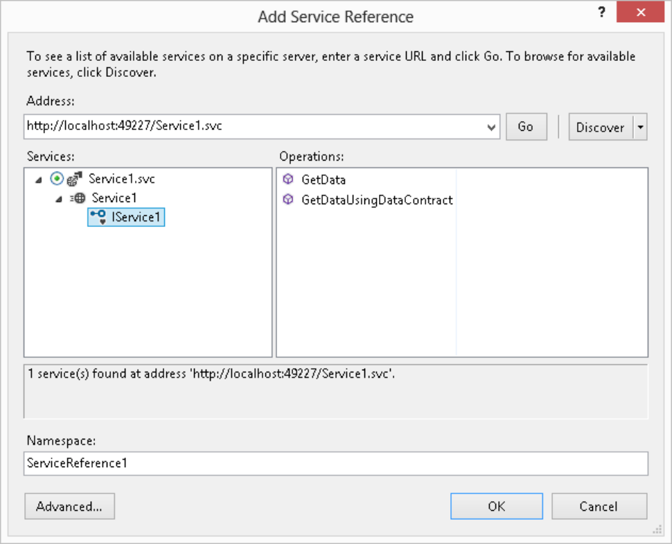
Figure 25-2 [314418 f2502.png]
7. Click OK to add the service reference.
8. Modify the code in Program.cs in the Ch25Ex01Client application as follows:
using System;
using System.Collections.Generic;
using System.Linq;
using System.Text;
using System.Threading.Tasks;
using Ch25Ex01Client.ServiceReference1;

namespace Ch25Ex01Client
{
class Program
{
static void Main(string[] args)
{
string numericInput = null;
int intParam;
do
{
Console.WriteLine(
″Enter an integer and press enter to call the WCF service.″);
numericInput = Console.ReadLine();
}
while (!int.TryParse(numericInput, out intParam));
Service1Client client = new Service1Client();
Console.WriteLine(client.GetData(intParam));
Console.WriteLine(″Press an key to exit.″);
Console.ReadKey();
}
}
}
9. Right-click the Ch25Ex01Client project in the Solution Explorer and select Set as StartUp Project.
10. Run the application. Enter a number in the console application window and press Enter. The result is shown in Figure 25-3.
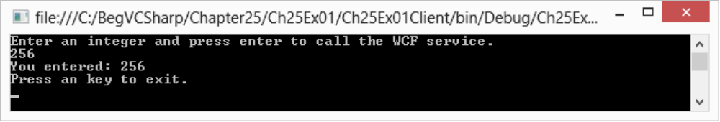
Figure 25-3 [314418 f2503.png]
11. Exit the application, right-click the Service1.svc file in the Ch25Ex01 project in the Solution Explorer, and click View in Browser.
12. Review the information in the window (see Figure 25-4).
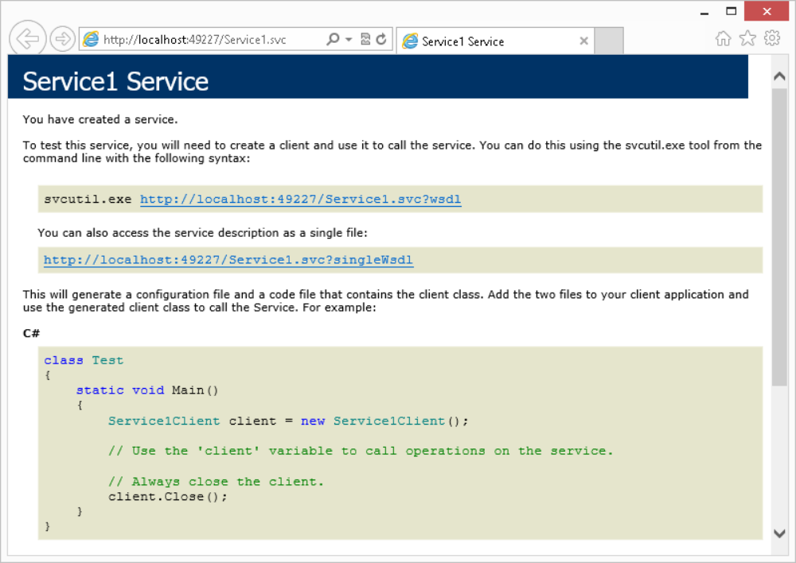
Figure 25-4 [314418 f2504.png]
13. Click the link at the top of the Web page for the service to view the WSDL. Don't panic—you don't need to know what all the stuff in the WSDL file means!

How It Works
In this example you created a simple Web server–hosted WCF service and console application client. You used the default VS template for a WCF service project, which meant that you didn't have to add any code. Instead, you used one of the operations defined in this default template, GetData(). For the purposes of this example, the actual operation used isn't important; here we are focusing on the structure of the code and the plumbing that makes things work.
First, look at the server project, Ch25Ex01. This consists of the following:
- A Service1.svc file that defines the hosting for the service
- A class definition, CompositeType, that defines a data contract used by the service (located in the IService1.cs code file)
- An interface definition, IService1, that defines the service contract and two operation contracts for the service
- A class definition, Service1, that implements IService1 and defines the functionality of the service (located in the Service1.svc.cs code file)
- A <system.serviceModel> configuration section (in Web.config) that configures the service
The Service1.svc file contains the following line of code (to see this code, right-click the file in the Solution Explorer and select View Markup):
AU: Karli, you will need to make sure that the code for these chapters is updated accordingly for the renumbered chapters.
I’m redoing all the code so hopefully we won’t have any problems.
<%@ ServiceHost Language=″C#″ Debug=″true″ Service=″Ch25Ex01.Service1″
CodeBehind=″Service1.svc.cs″ %>
This is a ServiceHost instruction that is used to tell the Web server (the development Web server in this case, although this also applies to IIS) what service is hosted at this address. The class that defines the service is declared in the Service attribute, and the code file that defines this class is declared in the CodeBehind attribute. This instruction is necessary in order to obtain the hosting features of the Web server as defined in the previous sections.
Obviously, this file is not required for WCF services that aren't hosted in a Web server. You'll learn how to self-host WCF services later in this chapter.
Next, the data contract CompositeType is defined in the IService1.cs file. You can see from the code that the data contract is simply a class definition that includes the DataContract attribute on the class definition and DataMember attributes on class members (you can find this code in Ch25Ex01\IService1.cs):
[DataContract]
public class CompositeType
{
bool boolValue = true;
string stringValue = ″Hello ″;

[DataMember]
public bool BoolValue
{
get { return boolValue; }
set { boolValue = value; }
}

[DataMember]
public string StringValue
{
get { return stringValue; }
set { stringValue = value; }
}
}
This data contract is exposed to the client application through metadata (if you looked through the WSDL file in the example you may have seen this). This enables client applications to define a type that can be serialized into a form that can be deserialized by the service into a CompositeType object. The client doesn't need to know the actual definition of this type; in fact, the class used by the client may have a different implementation. This simple way of defining data contracts is surprisingly powerful, and enables the exchange of complex data structures between the WCF service and its clients.
The IService1.cs file also contains the service contract for the service, which is defined as an interface with the ServiceContract attribute. Again, this interface is completely described in the metadata for the service, and can be recreated in client applications. The interface members constitute the operations exposed by the service, and each is used to create an operation contract by applying the OperationContract attribute. The example code includes two operations, one of which uses the data contract you looked at earlier:
[ServiceContract]
public interface IService1
{
[OperationContract]
string GetData(int value);

[OperationContract]
CompositeType GetDataUsingDataContract(CompositeType composite);
}
All four of the contract-defining attributes that you have seen so far can be further configured with attributes, as shown in the next section. The code that implements the service looks much like any other class definition (you can find this code in Ch25Ex01\Service1.svc.cs):
public class Service1 : IService1
{
public string GetData(int value)
{
return string.Format(″You entered: {0}″, value);
}

public CompositeType GetDataUsingDataContract(CompositeType composite)
{
if (composite == null)
{
throw new ArgumentNullException(″composite″);
}
if (composite.BoolValue)
{
composite.StringValue += ″Suffix″;
}
return composite;
}
}
Note that this class definition doesn't need to inherit from a particular type, and doesn't require any particular attributes. All it needs to do is implement the interface that defines the service contract. In fact, you can add attributes to this class and its members to specify behaviors, but these aren't mandatory.
The separation of the service contract (the interface) from the service implementation (the class) works extremely well. The client doesn't need to know anything about the class, which could include much more functionality than just the service implementation. A single class could even implement more than one service contract.
Finally, you come to the configuration in the Web.config file. Configuration of WCF services in config files is a feature that has been taken from .NET remoting, and it works with all types of WCF services (hosted or self-hosted) as well as clients of WCF services (as shown in a moment). The vocabulary of this configuration is such that you can apply pretty much any configuration that you can think of to a service, and you can even extend this syntax.
WCF configuration code is contained in the <system.serviceModel> configuration section of Web.config or app.config files. In this example, there is not a lot of service configuration, as default values are used. In the Web.config file, the configuration section consists of a single subsection that supplies overrides to default values for the service behavior <behaviors>. The code for the <system.serviceModel> configuration section in Web.config (with comments removed for clarity) is as follows (you can find this code in Ch25Ex01\Web.config):
<system.serviceModel>
<behaviors>
<serviceBehaviors>
<behavior>
<serviceMetadata httpGetEnabled=″true″ httpsGetEnabled="true"/>
<serviceDebug includeExceptionDetailInFaults=″false″/>
</behavior>
</serviceBehaviors>
</behaviors>
</system.serviceModel>
This section can define one or more behaviors in <behavior> child sections, which can be reused on multiple other elements. A <behavior> section can be given a name to facilitate this reuse (so that it can be referenced from elsewhere), or can be used without a name (as in this example) to specify overrides to default behavior settings.
type="note"
If nondefault configuration were being used, you would expect to see a <services> section inside <system.serviceModel>, containing one or more <services> child sections. In turn, the <service> sections can contain child <endpoint> sections, each of which (you guessed it) defines an endpoint for the service. In fact, the endpoints defined are base endpoints for the service. Endpoints for operations are inferred from these.
One of the default behavior overrides in Web.config is as follows:
<serviceDebug includeExceptionDetailInFaults=″false″/>
This setting can be set to true to expose exception details in any faults that are transmitted to the client, which is something you would usually allow only in development.
The other default behavior override in Web.config relates to metadata. Metadata is used to enable clients to obtain descriptions of WCF services. The default configuration defines two default endpoints for services. One is the endpoint that clients use to access the service, the other is an endpoint used to obtain metadata from the service. This can be disabled in the Web.config file as follows:
<serviceMetadata httpGetEnabled=″false″ httpsGetEnabled="false"/>
Alternatively, you could remove this line of configuration code entirely, as the default behavior does not enable metadata exchange.
If you try disabling this in the example it won't stop your client from being able to access the service, because it has already obtained the metadata it needed when you added the service reference. However, disabling metadata will prevent other clients from using the Add Service Reference tool for this service. Typically, Web services in a production environment will not need to expose metadata, so you should disable this functionality after the development phase is complete.
Without metadata, another common way to access a WCF service is to define its contracts in a separate assembly, which is referenced by both the hosting project and the client project. The client can then generate a proxy by using these contracts directly, rather than through exposed metadata.
Now that you've looked at the WCF service code, it's time to look at the client, and in particular at what using the Add Service Reference tool actually did. You will notice in the Solution Explorer that the client includes a folder called Service References, and if you expand that you will see an item called ServiceReference1, which was the name you chose when you added the reference.
The Add Service Reference tool creates all the classes you require to access the service. This includes a proxy class for the service that includes methods for all the operations exposed by the service (Service1Client), and a client-side class generated from the data contract (CompositeType).
type="note"
You can browse through the code that is generated by the Add Service Reference tool if you want (by displaying all files in the project, including the hidden ones), although at this point it's probably best not to, because it contains quite a lot of confusing code.
The tool also adds a configuration file to the project, app.config. This configuration defines two things:
- Binding information for the service endpoint
- The address and contract for the endpoint
The binding information is taken from the service description (you can find this code in Ch25Ex01Client\app.config):
<configuration>
<system.serviceModel>
<bindings>
<basicHttpBinding>
<binding name=″BasicHttpBinding_IService1″

/>
</basicHttpBinding>
</bindings>
This binding is used in the endpoint configuration, along with the base address of the service (which is the address of the .svc file for Web server–hosted services) and the client-side version of the contract IService1:
<client>
<endpoint address=″http://localhost:49227/Service1.svc″
binding=″basicHttpBinding″
bindingConfiguration=″BasicHttpBinding_IService1″
contract=″ServiceReference1.IService1″
name=″BasicHttpBinding_IService1″ />
</client>
</system.serviceModel>
</configuration>
Strictly speaking, you could replace this configuration file with the following:
<configuration>
<system.serviceModel>
<client>
<endpoint address=″http://localhost:51782/Service1.svc″
binding=″basicHttpBinding″
contract=″ServiceReference1.IService1″
name=″BasicHttpBinding_IService1″ />
</client>
</system.serviceModel>
</configuration>
Here, the <bindings> section as well as the bindingConfiguration attribute of the <endpoint> element have been removed, which means that the client will use the default binding configuration.
The reason that the BasicHttpBinding_IService1 binding was added for you is that you can use this to customize the configuration of the binding. There are a number of configuration settings that you might use here, ranging from timeout settings to message size limits and security settings. If these had been specified in the service project to be non-default values then you would have seen them in the app.config file, since they would have been copied across. In order for the client to communicate with the service, the binding configurations must match. You won't look at WCF service configuration in great depth in this chapter.
This example has covered a lot of ground, and it is worth summarizing what you have learned before moving on:
- WCF service definitions:
- Services are defined by a service contract interface that includes operation contract members.
- Services are implemented in a class that implements the service contract interface.
- Data contracts are simply type definitions that use data contract attributes.
- WCF service configuration:
- You can use configuration files (Web.config or app.config) to configure WCF services.
- WCF Web server hosting:
- Web server hosting uses .svc files as service base addresses.
- WCF client configuration:
- You can use configuration files (Web.config or app.config) to configure WCF service clients.
The following section explores contracts in more detail.

The WCF Test Client
In the previous Try It Out, you created both a service and a client in order to look at how the basic WCF architecture works and how configuration of WCF services is achieved. In practice, though, the client application you want to use may be complex, and it can be tricky to test services properly.
To ease the development of WCF services, VS provides a test tool you can use to ensure that your WCF operations work correctly. This tool is automatically configured to work with your WCF service projects, so if you run your project the tool will appear. All you need to do is ensure that the service you want to test (that is, the .svc file) is set to be the startup page for the WCF service project. Alternatively, you can run the test client as a standalone application. You can find the test client on 64-bit operating systems at C:\Program Files (x86)\Microsoft Visual Studio 11.0\Common7\IDE\WcfTestClient.exe.
If you are using a 32-bit operating system, the path is the same except the root folder is Program Files.
The tool enables you to invoke service operations and inspect the service in some other ways. The following Try It Out illustrates this.
type="activity"

Using the WCF Test Client: Ch25Ex01\Web.config
1. Open the WCF Service Application project from the previous Try It Out, Ch25Ex01.
2. Right-click the Service1.svc service in Solution Explorer and click Set As Start Page.
3. Right-click the Ch25Ex01 project in Solution Explorer and click Set As StartUp Project.
4. In Web.config, ensure that metadata is enabled:
<serviceMetadata httpGetEnabled=″true″ httpsGetEnabled="true"/>
5. Run the application. The WCF test client appears, as shown in Figure 25-5 (it takes a moment or two to add the service).
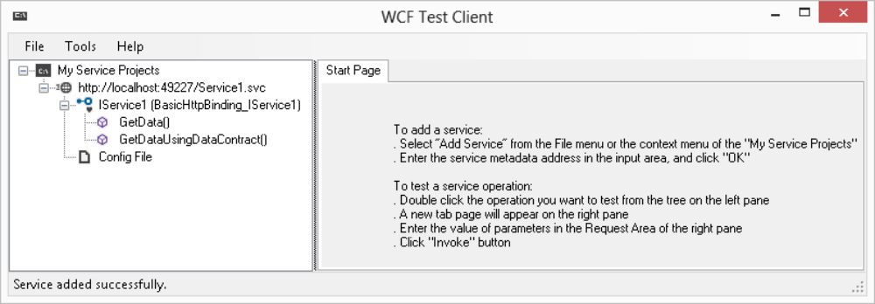
Figure 25-5 [314418 f2505.png]
6. In the left pane of the test client, double-click Config File. The config file used to access the service is displayed in the right pane, which is shown in Figure 25-6.
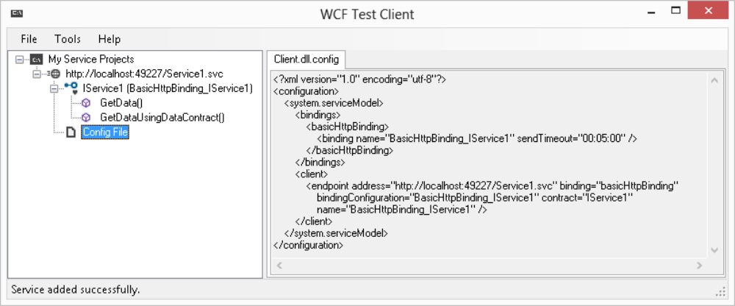
Figure 25-6 [314418 f2506.png]
7. In the left pane, double-click the GetDataUsingDataContract() operation.
8. In the pane that appears on the right, change the value of BoolValue to True and StringValue to Test String, and then click Invoke.
9. If a security prompt dialog appears, click OK to confirm that you are happy to send information to the service.
10. The operation result appears, as shown in Figure 25-7.
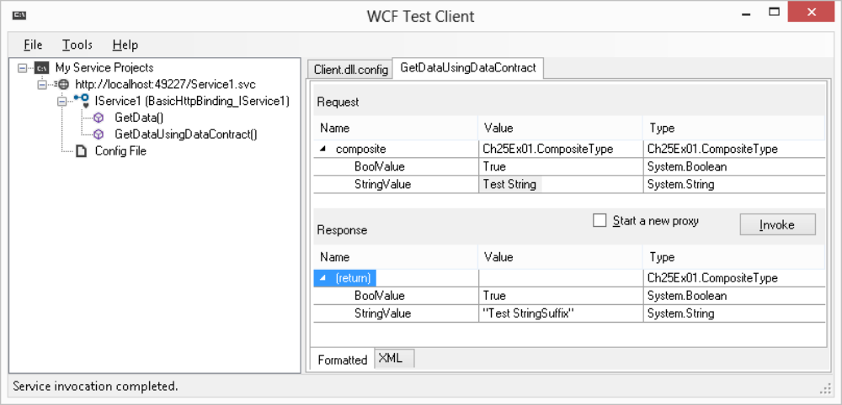
Figure 25-7 [314418 f2507.png]
11. Click the XML tab to view the request and response XML, shown in Figure 25-8.

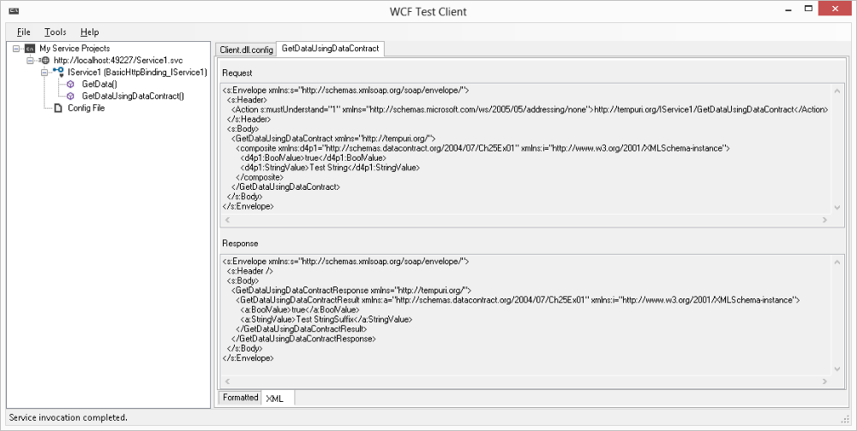

Figure 25-8 [314418 f2508.png]
How It Works
In this example you used the WCF test client to inspect and invoke an operation on the service you created in the previous Try It Out. The first thing you probably noticed was a slight delay while the service was loaded. This is because the test client had to inspect the service to determine its capabilities. This discovery uses the same metadata as the Add Service Reference tool, which is why you had to ensure that metadata was available (it's possible you experimented with disabling it in the previous Try It Out). Once discovery was complete, you saw the service and its operations in the left pane of the tool.
Next, you looked at the configuration used to access the service. As with the client application from the previous Try It Out, this was generated automatically from the service metadata, and contained exactly the same code. You can edit this configuration file through the tool if you need to, by right-clicking on the Config File item and clicking Edit with SvcConfigeditor. An example of this configuration is shown in Figure 25-9, which includes the binding configuration options mentioned earlier in this chapter:
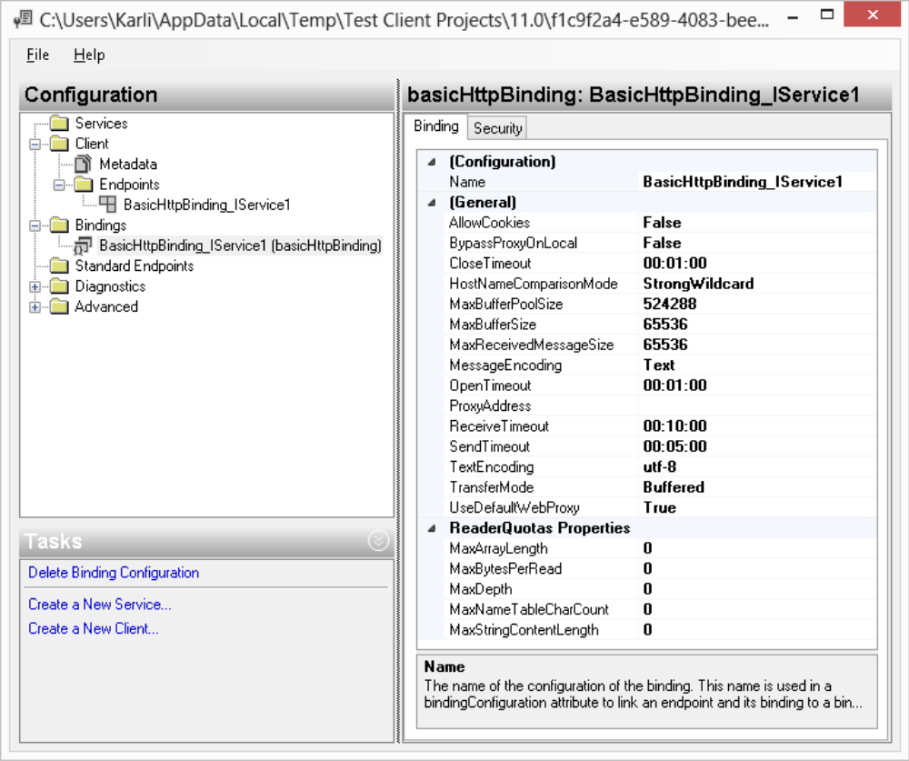
Figure 25-9 [314418 f2509.png]
Finally, you invoked an operation. The test client allows you to enter the parameters to use and invoke the method, then displays the result, all without you writing any client code. You also saw how to view the actual XML that was sent and received to obtain the result. This information is quite technical, but it can be absolutely critical when debugging more complex services.

Defining WCF Service Contracts
The previous examples showed how the WCF infrastructure makes it easy for you to define contracts for WCF services with a combination of classes, interfaces, and attributes. This section takes a deeper look at this technique.

Data Contracts
To define a data contract for a service, you apply the DataContractAttribute attribute to a class definition. This attribute is found in the System.Runtime.Serialization namespace. You can configure this attribute with the following properties:
Property | Description
Name | Names the data contract with a different name than the name you use for the class definition. This name will be used in SOAP messages and client-side data objects that are defined from service metadata.
Namespace | Defines the namespace that the data contract uses in SOAP messages.
IsReference | Affects the way that objects are serialized. If this is set to true then an object instance is only serialized once even if it is referenced several times, which can be important is some situations. The default is false.
The Name and Namespace properties are useful when you need interoperability with existing SOAP message formats (as are the similarly named properties for other contracts), but otherwise you will probably not require them.
Each class member that is part of a data contract must use the DataMemberAttribute attribute, which is also found in the System.Runtime.Serialization namespace. This attribute has the following properties:
Property | Description
Name | Specifies the name of the data member when serialized (the default is the member name).
IsRequired | Specifies whether the member must be present in a SOAP message.
Order | An int value specifying the order of serializing or deserializing the member, which may be required if one member must be present before another can be understood. Lower Order members are processed first.
EmitDefaultValue | Set this to false to prevent members from being included in SOAP messages if their value is the default value for the member.

Service Contracts
Service contracts are defined by applying the System.ServiceModel.ServiceContractAttribute attribute to an interface definition. You can customize the service contract with the following properties:
Property | Description
Name | Specifies the name of the service contract as defined in the <portType> element in WSDL.
Namespace | Defines the namespace of the service contract used by the <portType> element in WSDL.
ConfigurationName | The name of the service contract as used in the configuration file.
HasProtectionLevel | Determines whether messages used by the service have explicitly defined protection levels. Protection levels enable you to sign, or sign and encrypt, messages.
ProtectionLevel | The protection level to use for message protection.
SessionMode | Determines whether sessions are enabled for messages. If you use sessions, then you can ensure that messages sent to different endpoints of a service are correlated—that is, they use the same service instance and so can share state, etc.
CallbackContract | For duplex messaging the client exposes a contract as well as the service. This is because, as discussed earlier, the client in duplex communications also acts as a server. This property enables you to specify which contract the client uses.

Operation Contracts
Within interfaces that define service contracts, you define members as operations by applying the System.ServiceModel.OperationContractAttribute attribute. This attribute has the following properties:
Property | Description
Name | Specifies the name of the service operation. The default is the member name.
IsOneWay | Specifies whether the operation returns a response. If you set this to true, then clients won't wait for the operation to complete before continuing.
AsyncPattern | If set to true, the operation is implemented as two methods that you can use to call the operation asynchronously: Begin<methodName>() and End<methodName>().
HasProtectionLevel | See the previous section.
ProtectionLevel | See the previous section.
IsInitiating | If sessions are used, then this property determines whether calling this operation can start a new session.
IsTerminating | If sessions are used, then this property determines whether calling this operation terminates the current session.
Action | If you are using addressing (an advanced capability of WCF services), then an operation has an associated action name, which you can specify with this property.
ReplyAction | As above, but specifies the action name for the operation response.
type="note"
In the .NET 4.5 Framework, when you add a service reference VS also generates asynchronous proxy methods to call the service, regardless of whether AsyncPattern is set to true. These methods, which have the suffix Async, use the new asynchronous techniques that are included in .NET 4.5, and are only asynchronous from the point of view of the calling code. Internally, they call the synchronous WCF operations.

Message Contracts
The earlier example didn't use message contract specifications. If you use these, then you do so by defining a class that represents the message and applying the MessageContractAttribute attribute to the class. You then apply MessageBodyMemberAttribute, MessageHeaderAttribute, or MessageHeaderArrayAttribute attributes to members of this class. All these attributes are in the System.ServiceModel namespace. You are unlikely to want to do this unless you need a very high degree of control over the SOAP messages used by WCF services, so details are not provided here.

Fault Contracts
If you have a particular exception type—for example, a custom exception—that you want to make available to client applications, then you can apply the System.ServiceModel.FaultContractAttribute attribute to the operation that might generate this exception. Again, this isn't something you will want to do in ordinary WCF use.
type="activity"

WCF Contracts: Ch25Ex02Contracts
1. Create a new WCF Service Application project called Ch25Ex02 in the directory C:\BegVCSharp\Chapter25.
2. Add a class library project called Ch25Ex02Contracts to the solution and remove the Class1.cs file.
3. Add references to the System.Runtime.Serialization.dll and System.ServiceModel.dll assemblies to the Ch25Ex02Contracts project.
4. Add a class called Person to the Ch25Ex02Contracts project and modify the code in Person.cs as follows:
using System;
using System.Collections.Generic;
using System.Linq;
using System.Text;
using System.Threading.Tasks;
using System.Runtime.Serialization;

namespace Ch25Ex02Contracts
{
[DataContract]
public class Person
{
[DataMember]
public string Name { get; set; }

[DataMember]
public int Mark { get; set; }
}
}
5. Add an interface called IAwardService to the Ch25Ex02Contracts project and modify the code in IAwardService.cs as follows:
using System;
using System.Collections.Generic;
using System.Linq;
using System.Text;
using System.Threading.Tasks;
using System.ServiceModel;

namespace Ch25Ex02Contracts
{
[ServiceContract(SessionMode=SessionMode.Required)]
public interface IAwardService
{
[OperationContract(IsOneWay=true,IsInitiating=true)]
void SetPassMark(int passMark);

[OperationContract]
Person[] GetAwardedPeople(Person[] peopleToTest);
}
}
6. In the Ch25Ex02 project, add a reference to the Ch25Ex02Contracts project.
7. Remove IService1.cs and Service1.svc from the Ch25Ex02 project.
8. Add a new WCF service called AwardService to Ch25Ex02.
9. Remove the IAwardService.cs file from the Ch25Ex02 project.
10. Modify the code in AwardService.svc.cs as follows:
using System;
using System.Collections.Generic;
using System.Linq;
using System.Runtime.Serialization;
using System.ServiceModel;
using System.Text;
using Ch25Ex02Contracts;

namespace Ch25Ex02
{
public class AwardService : IAwardService
{
private int passMark;

public void SetPassMark(int passMark)
{
this.passMark = passMark;
}

public Person[] GetAwardedPeople(Person[] peopleToTest)
{
List<Person> result = new List<Person>();
foreach (Person person in peopleToTest)
{
if (person.Mark > passMark)
{
result.Add(person);
}
}
return result.ToArray();
}
}
}
11. Modify the service configuration section in Web.config as follows:
<system.serviceModel>
<protocolMapping>
<add scheme=″http″ binding=″wsHttpBinding″/>
</protocolMapping>
...
</system.serviceModel>
12. Open the project properties for Ch25Ex02. In the Web section, make a note of the port used in the hosting settings. If you don’t have IIS installed, you can set a specific port for use in the Visual Studio Development Server instead. For example, in Figure 25-10, the port used is 49284.
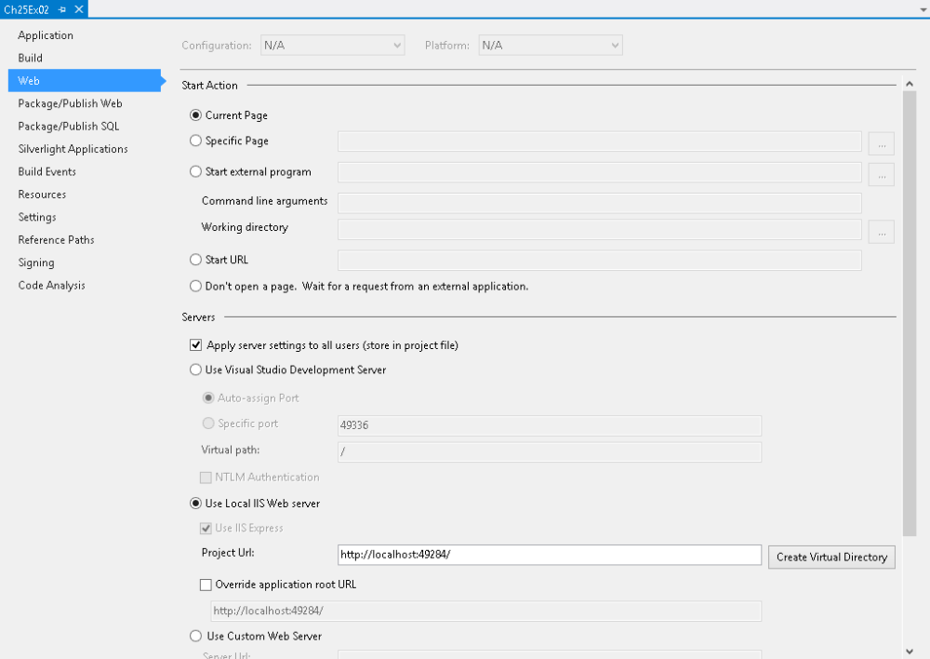
Figure 25-10 [314418 f2510.png]
13. Add a new console project called Ch25Ex02Client to the solution and set it as the startup project.
14. Add references to the System.ServiceModel.dll assembly and the Ch25Ex02Contracts project to the Ch25Ex02Client project.
15. Modify the code in Program.cs in Ch25Ex02Client as follows (ensure that you use the port number you obtained earlier in the EndpointAddress constructor, the example code uses port 49284):
using System;
using System.Collections.Generic;
using System.Linq;
using System.Text;
using System.Threading.Tasks;
using System.ServiceModel;
using Ch25Ex02Contracts;

namespace Ch25E02Client
{
class Program
{
static void Main(string[] args)
{
Person[] people = new Person[]
{
new Person { Mark = 46, Name=″Jim″ },
new Person { Mark = 73, Name=″Mike″ },
new Person { Mark = 92, Name=″Stefan″ },
new Person { Mark = 84, Name=″George″ },
new Person { Mark = 24, Name=″Arthur″ },
new Person { Mark = 58, Name=″Nigel″ }
};

Console.WriteLine(″People:″);
OutputPeople(people);

IAwardService client = ChannelFactory<IAwardService>.CreateChannel(
new WSHttpBinding(),
new EndpointAddress(″http://localhost:49284/AwardService.svc″));
client.SetPassMark(70);
Person[] awardedPeople = client.GetAwardedPeople(people);

Console.WriteLine();
Console.WriteLine(″Awarded people:″);
OutputPeople(awardedPeople);

Console.ReadKey();
}

static void OutputPeople(Person[] people)
{
foreach (Person person in people)
{
Console.WriteLine(″{0}, mark: {1}″, person.Name, person.Mark);
}
}
}
}
16. If you are using IIS, simply run the application. If you are using the development server, you must ensure the development server is running for the service, so run the service project first. The end result is shown in Figure 25-11.

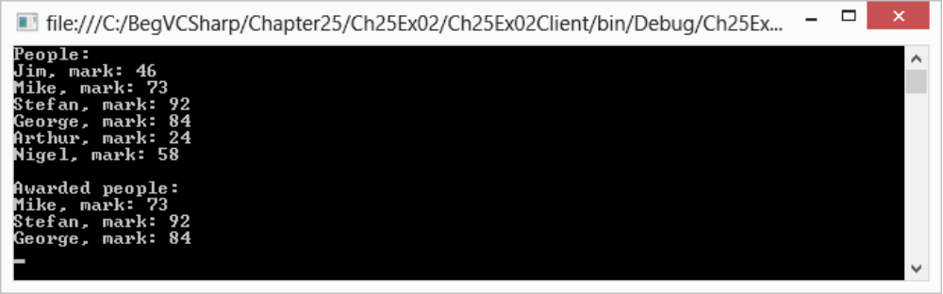
Figure 25-11 [314418 f2511.eps]
How It Works
In this example, you have created a set of contracts in a class library project and used that class library in both a WCF service and a client. The service, as in the previous example, is hosted in a Web server. The configuration for this service was reduced to the bare minimum.
The main difference in this example is that no metadata was required by the client, as the client had access to the contract assembly. Instead of generating a proxy class from metadata, the client obtained a reference to the service contract interface through an alternative method. Another point to note about this example is the use of a session to maintain state in the service, which requires the WSHttpBinding binding instead of the BasicHttpBinding binding.
The data contract used in this example was for a simple class called Person, which has a string property called Name and an int property called Mark. You used the DataContractAttribute and DataMemberAttribute attributes with no customization, and there is no need to reiterate the code for this contract here.
The service contract was defined by applying the ServiceContractAttribute attribute to the IAwardService interface. The SessionMode property of this attribute was set to SessionMode.Required, as this service requires state:
[ServiceContract(SessionMode=SessionMode.Required)]
public interface IAwardService
{
The first operation contract, SetPassMark(), is the one that sets state, and therefore has the IsInitiating property of OperationContractAttribute set to true. This operation doesn't return anything, so it is defined as a one-way operation by setting IsOneWay to true:
[OperationContract(IsOneWay=true,IsInitiating=true)]
void SetPassMark(int passMark);
The other operation contract, GetAwardedPeople(), does not require any customization and uses the data contract defined earlier:
[OperationContract]
Person[] GetAwardedPeople(Person[] peopleToTest);
}
Remember that these two types, Person and IAwardService, are available to both the service and the client. The service implements the IAwardService contract in a type called AwardService, which doesn't contain any remarkable code. The only difference between this class and the service class you saw earlier is that it is stateful. This is permissible, as a session is defined to correlate messages from a client.
To ensure that the service uses the WSHttpBinding binding, you added the following the Web.config for the service:
<protocolMapping>
<add scheme=″http″ binding=″wsHttpBinding″/>
</protocolMapping>
This overrides the default mapping for HTTP binding. Alternatively, you could configure the service manually and keep the existing default, but this override is much simpler. However, be aware that this type of override is applied to all services in a project. If you have more than one service in a project, then you would have to ensure that this binding is acceptable to each of them.
The client is more interesting, primarily because of this line of code:
IAwardService client = ChannelFactory<IAwardService>.CreateChannel(
new WSHttpBinding(),
new EndpointAddress(″http://localhost:49284/AwardService.svc″));
The client application has no app.config file to configure communications with the service, and no proxy class defined from metadata to communicate with the service. Instead, a proxy class is created through the ChannelFactory<T>.CreateChannel() method. This method creates a proxy class that implements the IAwardService client, although behind the scenes the generated class communicates with the service just like the metadata-generated proxy shown earlier.
type="note"
If you create a proxy class with ChannelFactory<T>.CreateChannel(), the communication channel will, by default, time out after a minute, which can lead to communication errors. There are ways to keep connections alive, but they are beyond the scope of this chapter.
Creating proxy classes in this way is an extremely useful technique that you can use to quickly generate a client application on-the-fly.

Self-Hosted WCF Services
So far in this chapter you have seen WCF services that are hosted in Web servers. This enables you to communicate across the Internet, but for local network communications it is not the most efficient way of doing things. For one thing, you need a Web server on the computer that hosts the service. In addition, the architecture of your applications may be such that having an independent WCF service may not be desirable.
Instead, you might want to use a self-hosted WCF service. A self-hosted WCF service is a service that exists in a process that you create, rather than in the process of a specially made hosting application such as a Web server. This means, for example, that you can use a console application or Windows application to host your service.
To self-host a WCF service, you use the System.ServiceModel.ServiceHost class. You instantiate this class with either the type of the service you want to host or an instance of the service class. You can configure a service host through properties or methods, or (and this is the clever part) through a configuration file. In fact, host processes, such as Web servers, use a ServiceHost instance to do their hosting. The difference when self-hosting is that you interact with this class directly. However, the configuration you place in the <system.serviceModel> section of the app.config file for your host application uses exactly the same syntax as the configuration sections you've already seen in this chapter.
You can expose a self-hosted service through any protocol that you like, although typically you will use TCP or named pipe binding in this type of application. Services accessed through HTTP are more likely to live inside Web server processes, because you get the additional functionality that Web servers offer, such as security and other features.
If you want to host a service called MyService, you could use code such as the following to create an instance of ServiceHost:
ServiceHost host = new ServiceHost(typeof(MyService));
If you want to host an instance of MyService called myServiceObject, you could code as follows to create an instance of ServiceHost:
MyService myServiceObject = new MyService();
ServiceHost host = new ServiceHost(myServiceObject);
type="warning"
Hosting a service instance in a ServiceHost works only if you configure the service so that calls are always routed to the same object instance. To do this you must apply a ServiceBehaviorAttribute attribute to the service class and set the InstanceContextMode property of this attribute to InstanceContextMode.Single.
After creating a ServiceHost instance you can configure the service and its endpoints and binding through properties. Alternatively, if you put your configuration in a .config file, the ServiceHost instance will be configured automatically.
To start hosting a service once you have a configured ServiceHost instance, you use the ServiceHost.Open() method. Similarly, you stop hosting the service through the ServiceHost.Close() method. When you first start hosting a TCP-bound service, you may, if you have it enabled, receive a warning from the Windows Firewall service, as it will block the TCP port by default. You must open the TCP port for the service to begin listening on the port.
In the following Try it Out you use self-hosting techniques to expose some functionality of a WPF application through a WCF service.
type="activity"

Self-Hosted WCF Services: Ch25Ex03
1. Create a new WPF application called Ch25Ex03 in the directory C:\BegVCSharp\Chapter25.
2. Add a new WCF service to the project called AppControlService by using the Add New Item Wizard.
3. Modify the code in MainWindow.xaml as follows:
<Window x:Class=″Ch25Ex03.MainWindow″
xmlns=″http://schemas.microsoft.com/winfx/2006/xaml/presentation″
xmlns:x=″http://schemas.microsoft.com/winfx/2006/xaml″

Title=″Stellar Evolution″ Height=″450″ Width=″430″
Loaded=″Window_Loaded″ Closing=″Window_Closing″>
<Grid Height=″400″ Width=″400″ HorizontalAlignment=″Center″
VerticalAlignment=″Center″>
<Rectangle Fill=″Black″ RadiusX=″20″ RadiusY=″20″
StrokeThickness=″10″>
<Rectangle.Stroke>
<LinearGradientBrush EndPoint=″0.358,0.02″
StartPoint=″0.642,0.98″>
<GradientStop Color=″#FF121A5D″ Offset=″0″/>
<GradientStop Color=″#FFB1B9FF″ Offset=″1″/>
</LinearGradientBrush>
</Rectangle.Stroke>
</Rectangle>
<Ellipse Name=″AnimatableEllipse″ Stroke=″{x:Null}″ Height=″0″
Width=″0″ HorizontalAlignment=″Center″
VerticalAlignment=″Center″>
<Ellipse.Fill>
<RadialGradientBrush>
<GradientStop Color=″#FFFFFFFF″ Offset=″0″/>
<GradientStop Color=″#FFFFFFFF″ Offset=″1″/>
</RadialGradientBrush>
</Ellipse.Fill>
<Ellipse.Effect>
<DropShadowEffect ShadowDepth=″0″ Color=″#FFFFFFFF″
BlurRadius=″50″/>
</Ellipse.Effect>
</Ellipse>
</Grid>
</Window>
4. Modify the code in MainWindow.xaml.cs as follows:
using System.Windows.Shapes;
using System.ServiceModel;
using System.Windows.Media.Animation;

namespace Ch25Ex03
{
/// <summary>
/// Interaction logic for MainWindow.xaml
/// </summary>
public partial class MainWindow : Window
{
private AppControlService service;
private ServiceHost host;

public MainWindow()
{
InitializeComponent();
}

private void Window_Loaded(object sender, RoutedEventArgs e)
{
service = new AppControlService(this);
host = new ServiceHost(service);
host.Open();
}

private void Window_Closing(object sender,
System.ComponentModel.CancelEventArgs e)
{
host.Close();
}

internal void SetRadius(double radius, string foreTo,
TimeSpan duration)
{
if (radius > 200)
{
radius = 200;
}
Color foreToColor = Colors.Red;
try
{
foreToColor =
(Color)ColorConverter.ConvertFromString(foreTo);
}
catch
{
// Ignore color conversion failure.
}
Duration animationLength = new Duration(duration);

DoubleAnimation radiusAnimation = new DoubleAnimation(
radius * 2, animationLength);
ColorAnimation colorAnimation = new ColorAnimation(
foreToColor, animationLength);
AnimatableEllipse.BeginAnimation(Ellipse.HeightProperty,
radiusAnimation);
AnimatableEllipse.BeginAnimation(Ellipse.WidthProperty,
radiusAnimation);
((RadialGradientBrush)AnimatableEllipse.Fill).GradientStops[1]
.BeginAnimation(GradientStop.ColorProperty, colorAnimation);
}
}
}
5. Modify the code in IAppControlService.cs as follows:
[ServiceContract]
public interface IAppControlService
{
[OperationContract]
void SetRadius(int radius, string foreTo, int seconds);
}
6. Modify the code in AppControlService.cs as follows:
[ServiceBehavior(InstanceContextMode=InstanceContextMode.Single)]
public class AppControlService : IAppControlService
{
private MainWindow hostApp;

public AppControlService(MainWindow hostApp)
{
this.hostApp = hostApp;
}

public void SetRadius(int radius, string foreTo, int seconds)
{
hostApp.SetRadius(radius, foreTo, new TimeSpan(0, 0, seconds));
}
}
7. Modify the code in app.config as follows:
<configuration>
<system.serviceModel>
<services>
<service name=″Ch25Ex03.AppControlService″>
<endpoint address=″net.tcp://localhost:8081/AppControlService″
binding=″netTcpBinding″
contract=″Ch25Ex03.IAppControlService″ />
</service>
</services>
</system.serviceModel>
</configuration>
8. Add a new console application to the project called Ch25Ex03Client.
9. Right-click the solution in the Solution Explorer and click Set StartUp Projects.
10. Configure the solution to have multiple startup projects, with both projects being started simultaneously, as shown in Figure 25-12.
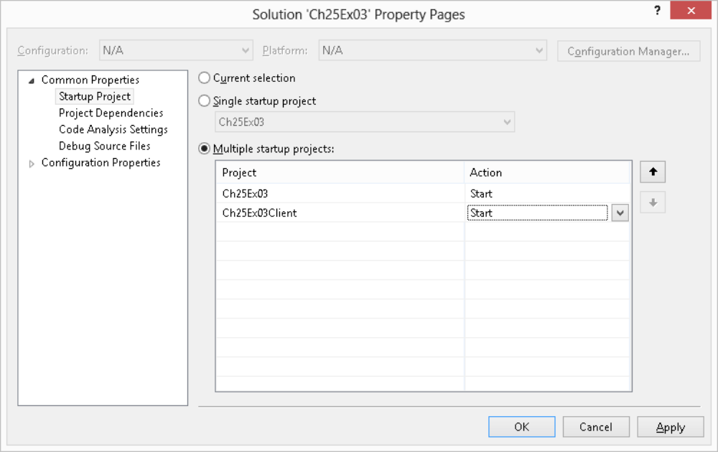
Figure 25-12 [314418 f2512.png]
11. Add references to System.ServiceModel.dll and Ch25Ex03 to the Ch25Ex03Client project.
12. Modify the code in Program.cs as follows:
using System;
using System.Collections.Generic;
using System.Linq;
using System.Text;
using System.Threading.Tasks;
using Ch25Ex03;
using System.ServiceModel;

namespace Ch25Ex03Client
{
class Program
{
static void Main(string[] args)
{
Console.WriteLine(″Press enter to begin.″);
Console.ReadLine();
Console.WriteLine(″Opening channel.″);
IAppControlService client =
ChannelFactory<IAppControlService>.CreateChannel(
new NetTcpBinding(),
new EndpointAddress(
″net.tcp://localhost:8081/AppControlService″));
Console.WriteLine(″Creating sun.″);
client.SetRadius(100, ″yellow″, 3);
Console.WriteLine(″Press enter to continue.″);
Console.ReadLine();
Console.WriteLine(″Growing sun to red giant.″);
client.SetRadius(200, ″Red″, 5);
Console.WriteLine(″Press enter to continue.″);
Console.ReadLine();
Console.WriteLine(″Collapsing sun to neutron star.″);
client.SetRadius(50, ″AliceBlue″, 2);
Console.WriteLine(″Finished. Press enter to exit.″);
Console.ReadLine();
}
}
}
13. Run the solution. If prompted, unblock the Windows Firewall TCP port so that the WCF can listen for connections.
14. When both the Solar Evolution window and the console application window are displayed, press Enter in the console window. The result is shown in Figure 25-13.
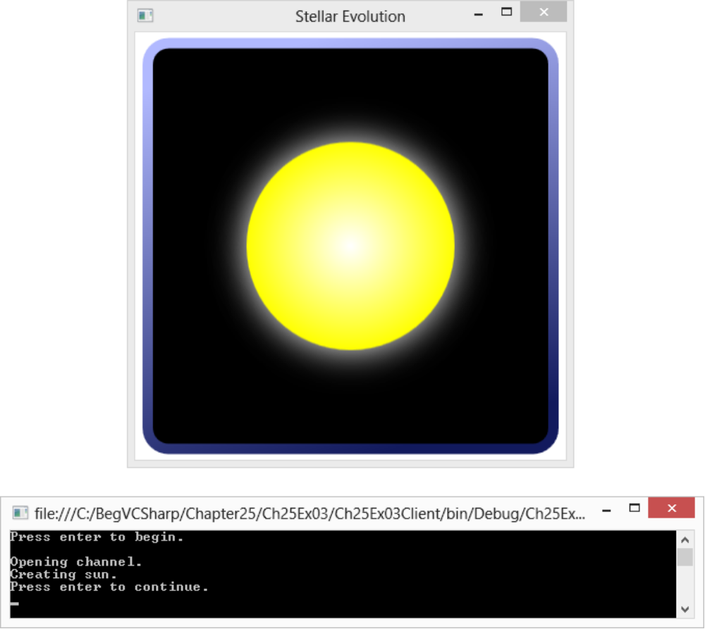
Figure 25-13 [314418 f2513.png]
15. Continue pressing Enter in the console window to continue the stellar evolution cycle.

How It Works
In this example you have added a WCF service to a WPF application and used it to control the animation of an Ellipse control. You have created a simple client application to test the service. Don't worry too much about the XAML code in this example if you are not familiar with WPF yet; it's the WCF plumbing that interests us here.
The WCF service, AppControlService, exposes a single operation, SetRadius(), which clients call to control the animation. This method communicates with an identically named method defined in the Window1 class for the WPF application. For this to work, the service needs a reference to the application, so you must host an object instance of the service. As discussed previously, this means that the service must use a behavior attribute:
[ServiceBehavior(InstanceContextMode=InstanceContextMode.Single)]
public class AppControlService : IAppControlService
{
...
}
In Window1.xaml.cs, the service instance is created in the Windows_Loaded() event handler. This method also begins hosting by creating a ServiceHost object for the service and calling its Open() method:
public partial class Window1 : Window
{
private AppControlService service;
private ServiceHost host;

...

private void Window_Loaded(object sender, RoutedEventArgs e)
{
service = new AppControlService(this);
host = new ServiceHost(service);
host.Open();
}
When the application closes, hosting is terminated in the Window_Closing() event handler.
The configuration file is again about as simple as it can be. It defines a single endpoint for the WCF service that listens at a net.tcp address, on port 8081, and uses the default NetTcpBinding binding:
<service name=″Ch25Ex03.AppControlService″>
<endpoint address=″net.tcp://localhost:8081/AppControlService″
binding=″netTcpBinding″
contract=″Ch25Ex03.IAppControlService″ />
</service>
This matches up with code in the client app:
IAppControlService client =
ChannelFactory<IAppControlService>.CreateChannel(
new NetTcpBinding(),
new EndpointAddress(
″net.tcp://localhost:8081/AppControlService″));
When the client has created a client proxy class, it can call the SetRadius() method with radius, color, and animation duration parameters, and these are forwarded to the WPF application through the service. Simple code in the WPF application then defines and uses animations to change the size and color of the ellipse.
This code would work across a network if you used a machine name, rather than localhost, and if the network permitted traffic on the specified port. Alternatively, you could separate the client and host application further, and connect across the Internet. Either way, WCF services provide an excellent means of communication that doesn't take much effort to set up.

Summary
In this chapter you looked at the basic techniques for using WCF services to communicate between applications, processes, and computers. You started by learning what a WCF service is and how it differs from a Web service or a remoting implementation, and the concepts that you need to know about to use WCF services. You then looked at how to program WCF services, how to consume WCF services in clients, and how to host WCF services in various ways.
What you have learned is the absolute minimum that you need in order to use WCF services in your applications. This barely scratches the surface of what is possible, in particular with .config file configuration and behaviors. The WCF framework enables you to integrate with advanced security infrastructures, and communication can be customized in pretty much any way you can imagine.
If you want to learn more about WCF services, you might like to read Professional WCF 4 (Wrox, available June 2010). In the next chapter, you look at the last of the major new technologies introduced with .NET 3.5 (and greatly improved for .NET 4 and .NET 4.5): Workflow Foundation.
[AU: Ed - Please update book reference above if known?]

Exercises
[AU: Karli: Please add the answers under the questions so they can be reviewed by the TE and CE. They can be stripped out during AR. Thanks]
25.1 Which of the following applications can host WCF services?
a. Web applications
b. Windows Forms applications
c. Windows services
d. COM+ applications
e. Console applications
25.2 Which type of contract would you implement if you wanted to exchange parameters of type MyClass with a WCF service? Which attributes would you require?
25.3 If you host a WCF service in a Web application, what extension will the base endpoint for the service use?
25.4 When self-hosting WCF services, you must configure the service by setting properties and calling methods of the ServiceHost class. True or false?
25.5 Provide the code for a service contract, IMusicPlayer, with operations defined for Play(), Stop(), and GetTrackInformation(). Use one-way methods where appropriate. What other contracts might you define for this service to work?
Answers to Exercises can be found in Appendix A.

Chapter 25 Solutions

Exercise 1
All of the above

Exercise 2
A data contract, with DataContractAttribute and DataMemberAttribute attributes

Exercise 3
Use the .svc extension

Exercise 4
That is one way of doing things, but it is usually easier to put all your WCF configuration in a separate configuration file, either web.config or app.config.

Exercise 5
[ServiceContract]
public interface IMusicPlayer
{
[OperationContract(IsOneWay=true)]
void Play();

[OperationContract(IsOneWay=true)]
void Stop();

[OperationContract]
TrackInformation GetCurrentTrackInformation();
}
You would also want a data contract to encapsulate track information; TrackInformation in the preceding code.
What You Learned in this Chapter section starts on new page.

What You Learned in this Chapter
Topic | Key Concepts
WCF fundamentals | WCF provides a framework for creating and communicating with remote services. It combines elements of the Web service and remoting architectures along with new technologies to achieve this.
Communication protocols | You can communicate with a WCF service by any one of several protocols, including HTTP and TCP. This means that you can use services that are local to your client application, or that are separated by machine or network boundaries. To do this, you access a specific endpoint for the service through a binding corresponding to the protocol and features that you require. You can control these features, such as using session state or exposing metadata, through behaviors. .NET 4.5 includes many default settings to make it very easy to define a simple service.
Communication payload | Typically, calls to responses from WCF services are encoded as SOAP messages. However, there are alternatives, such as plain HTTP messages, and you can define your own payload types from scratch if you need to.
Hosting | WCF services may be hosted in IIS or in a Windows service, or they can be self-hosted. Using a host such as IIS enables you to make use of the host's built-in capabilities, including security and application pooling. Self-hosting is more flexible, but it can require more configuration and coding.
Contracts | You define the interface between a WCF service and client code through contracts. Services themselves, along with any operations they expose, are defined with service and operation contracts. Data types are defined with data contracts. Further customization of communications is achieved with message and fault contracts.
Client applications | Client applications communicate with WCF services by means of a proxy class. Proxy classes implement the service contract interface for the service, and any calls to operation methods of this interface are redirected to the service. You can generate a proxy by using the Add Service Reference tool, or you can create one programmatically through channel factory methods. In order for communications to succeed, the client must be configured to match the service configuration.
[INSERT agr001.tif]

